SMTP Server

📡 What is an SMTP Server?
# Source: AI Source: Provided by: [Data Path: Persons Table -> ID Column: 1, Name_En Column: Motasem Essam] -> From: [ChatGPT] on [1/21/2026]
An SMTP server is a mail server that sends and routes emails using the Simple Mail Transfer Protocol (SMTP).
In simple terms:
An SMTP server is like a postal hub that accepts your outgoing emails and delivers them to recipients across the internet.

what mean of routes emails

📬 What does it mean to "route emails"?
# Source: AI Source: Provided by: [Data Path: Persons Table -> ID Column: 1, Name_En Column: Motasem Essam] -> From: [ChatGPT] on [1/21/2026]
To route emails means to direct them to the correct destination based on rules, addresses, or domains — just like routing traffic on a road or sorting physical mail in a post office.

🧠 Think of it like this:
# Source: AI Source: Provided by: [Data Path: Persons Table -> ID Column: 1, Name_En Column: Motasem Essam] -> From: [ChatGPT] on [1/21/2026]
- 🏤 You drop a letter into the mailbox (send an email)
- 📮 The post office (SMTP server) checks the address
- 🚚 Routes the letter toward the recipient’s city and home (email domain and inbox)

📡 In email terms:
# Source: AI Source: Provided by: [Data Path: Persons Table -> ID Column: 1, Name_En Column: Motasem Essam] -> From: [ChatGPT] on [1/21/2026]
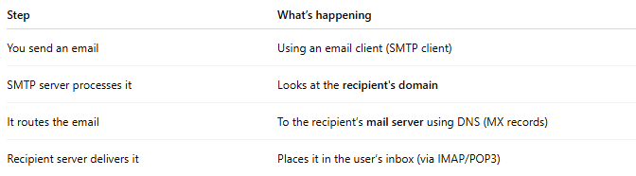

Step | What’s happening
You send an email | Using an email client (SMTP client)
SMTP server processes it | Looks at the recipient's domain
It routes the email | To the recipient’s mail server using DNS (MX records)
Recipient server delivers it | Places it in the user’s inbox (via IMAP/POP3)

🧭 Routing Examples:

1. Normal routing
# Source: AI Source: Provided by: [Data Path: Persons Table -> ID Column: 1, Name_En Column: Motasem Essam] -> From: [ChatGPT] on [1/21/2026]
- You send to: user@example.com
- Your SMTP server queries DNS for example.com → finds MX record
- Email is routed to mail.example.com

2. Custom routing
# Source: AI Source: Provided by: [Data Path: Persons Table -> ID Column: 1, Name_En Column: Motasem Essam] -> From: [ChatGPT] on [1/21/2026]
You can set up custom routing:
- Emails to support@yourcompany.com go to Zendesk
- Emails to jobs@yourcompany.com forward to HR
- Or route through anti-spam filters like Postmark or SpamTitan

3. Failover routing
# Source: AI Source: Provided by: [Data Path: Persons Table -> ID Column: 1, Name_En Column: Motasem Essam] -> From: [ChatGPT] on [1/21/2026]
- If the first server fails, it tries the backup MX server

📌 Email Routing Use Cases:
# Source: AI Source: Provided by: [Data Path: Persons Table -> ID Column: 1, Name_En Column: Motasem Essam] -> From: [ChatGPT] on [1/21/2026]
- Company email systems (route to different departments)
- Email security (route through anti-spam scanners)
- Development tools (route to MailHog or Mailtrap for testing)
- Email forwarding services (Gmail can fetch mail from another domain)

✅ Summary
# Source: AI Source: Provided by: [Data Path: Persons Table -> ID Column: 1, Name_En Column: Motasem Essam] -> From: [ChatGPT] on [1/21/2026]
Routing emails means:
“Deciding where to send the email next, based on its recipient address and server configuration.”
It ensures your email gets from sender to receiver through the correct path.

🧠 Real-World Analogy:
# Source: AI Source: Provided by: [Data Path: Persons Table -> ID Column: 1, Name_En Column: Motasem Essam] -> From: [ChatGPT] on [1/21/2026]
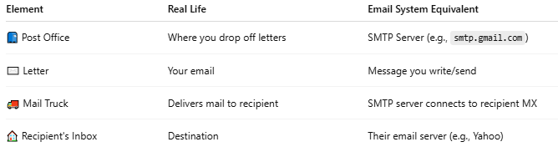

Element | Real Life | Email System Equivalent
📮 Post Office | Where you drop off letters | SMTP Server (e.g., smtp.gmail.com)
✉️ Letter | Your email | Message you write/send
🚚 Mail Truck | Delivers mail to recipient | SMTP server connects to recipient MX
🏠 Recipient's Inbox | Destination | Their email server (e.g., Yahoo)

📤 What does an SMTP Server do?
# Source: AI Source: Provided by: [Data Path: Persons Table -> ID Column: 1, Name_En Column: Motasem Essam] -> From: [ChatGPT] on [1/21/2026]
- Receives your email from an SMTP client (e.g., PHPMailer, Outlook)
- Authenticates the sender (if required)
- Relays the email to the recipient’s email server using DNS & MX records
- Handles errors (invalid address, spam filters, etc.)

✅ Example SMTP Servers
# Source: AI Source: Provided by: [Data Path: Persons Table -> ID Column: 1, Name_En Column: Motasem Essam] -> From: [ChatGPT] on [1/21/2026]
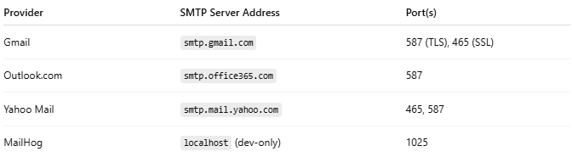

Provider | SMTP Server Address | Port(s)
Gmail | smtp.gmail.com | 587 (TLS), 465 (SSL)
Outlook.com | smtp.office365.com | 587
Yahoo Mail | smtp.mail.yahoo.com | 465, 587
MailHog | localhost (dev-only) | 1025

⚙️ SMTP Server Configuration Example (in PHPMailer):
# Source: AI Source: Provided by: [Data Path: Persons Table -> ID Column: 1, Name_En Column: Motasem Essam] -> From: [ChatGPT] on [1/21/2026]
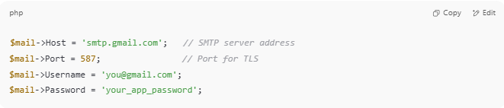
$mail->Host = 'smtp.gmail.com'; // SMTP server address
$mail->Port = 587; // Port for TLS
$mail->Username = 'you@gmail.com';
$mail->Password = 'your_app_password';

🔒 Security
# Source: AI Source: Provided by: [Data Path: Persons Table -> ID Column: 1, Name_En Column: Motasem Essam] -> From: [ChatGPT] on [1/21/2026]
Most modern SMTP servers use:
- ✅ TLS/SSL encryption
- ✅ Login authentication
- ✅ SPF, DKIM, DMARC to prevent spoofing/spam

🚫 Not a Mailbox
# Source: AI Source: Provided by: [Data Path: Persons Table -> ID Column: 1, Name_En Column: Motasem Essam] -> From: [ChatGPT] on [1/21/2026]
An SMTP server sends email only — it does not store incoming mail.
To receive email, you need IMAP or POP3 (e.g., imap.gmail.com).

🧪 Example SMTP server types:
# Source: AI Source: Provided by: [Data Path: Persons Table -> ID Column: 1, Name_En Column: Motasem Essam] -> From: [ChatGPT] on [1/21/2026]
- Public: Gmail, Outlook, Yahoo
- Private/Corporate: Exchange, Postfix, Exim, etc.
- Dev/Test: MailHog, FakeSMTP, Mailtrap

